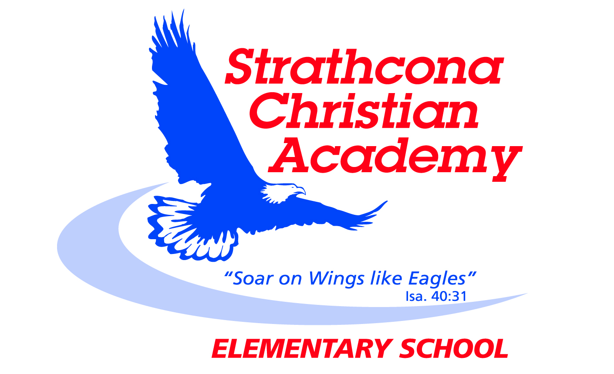
Grade 6 Bible Memory

Month | Week | Verse
SEPTEMBER | Week 1 | 1 John 1:9*  If we confess our sins, he is faithful and just and will forgive us our sins and purify us from all unrighteousness.
 | Week 2 | 1 Peter 3:15*  Always be prepared to give an answer to everyone who asks you to give the reason for the hope that you have. But do this with gentleness and respect.
 | Week 3 | Galatians 6:7*  Do not be deceived: God cannot be mocked. A man reaps what he sows.
OCTOBER | Week 1 | Matthew 5:16*  In the same way, let your light shine before others, that they may see your good deeds and glorify your Father in heaven.
 | Week 2 | Proverbs 3:5*  Trust in the Lord with all your heart and lean not on your own understanding;
 | Week 3 | Proverbs 3:6*  in all your ways submit to him, and he will make your paths straight.
NOVEMBER  NOVEMBER | Week 1 | Proverbs 3:5, 6*  ⁵ Trust in the Lord with all your heart and lean not on your own understanding; ⁶ in all your ways submit to him, and he will make your paths straight.
 | Week 2 | Jeremiah 29:11*  ¹¹ For I know the plans I have for you,” declares the Lord, “plans to prosper you and not to harm you, plans to give you hope and a future.”
 | Week 3 | John 3:16  For God so loved the world that he gave his one and only Son, that whoever believes in him shall not perish but have eternal life.
DECEMBER | Week 1 | Matthew 28:19  Therefore go and make disciples of all nations, baptizing them in the name of the Father and of the Son and of the Holy Spirit.
 | Week 2 | Matthew 7:12  So in everything, do to others what you would have them do to you, for this sums up the Law and the Prophets.
 | Week 3 | Galatians 5:22,23  ²² But the fruit of the Spirit is love, joy, peace, patience, kindness, goodness, faithfulness, ²³ gentleness and self-control. Against such things there is no law.
JANUARY | Week 1 | John 14:6  Jesus answered, “I am the way and the truth and the life. No one comes to the Father except through me.”
 | Week 2 | Romans 3:23  ²³ For all have sinned and fall short of the glory of God.
 | Week 3 | Romans 6:23  For the wages of sin is death, but the gift of God is eternal life in Christ Jesus our Lord.
FEBRUARY | Week 1 | Romans 5:8  But God demonstrates his own love for us in this: While we were still sinners, Christ died for us.
 | Week 2 | Romans 10:9  If you declare with your mouth, “Jesus is Lord,” and believe in your heart that God raised him from the dead, you will be saved.
 | Week 3 | 2 Timothy 3:16, 17  ¹⁶ All Scripture is God-breathed and is useful for teaching, rebuking, correcting and training in righteousness, ¹⁷ so that the servant of God may be thoroughly equipped for every good work.
MARCH | Week 1 | Micah 6:8  ⁸ He has shown you, O man, what is good. And what does the Lord require of you? To act justly and to love mercy  and to walk humbly with your God.
 | Week 2 | Psalm 119:11  ¹¹ I have hidden your word in my heart that I might not sin against you.
 | Week 3 | Genesis 1:1  In the beginning God created the heavens and the earth.
APRIL | Week 1 | Philippians 4:13  I can do everything through him who gives me strength.
 | Week 2 | 1 Corinthians 10:13  ¹³ No temptation has overtaken you except what is common to mankind. And God is faithful; he will not let you be tempted beyond what you can bear. But when you are tempted, he will also provide a way out so that you can endure it.
 | Week 3 | 1 John 1:9*  If we confess our sins, he is faithful and just and will forgive us our sins and purify us from all unrighteousness.
MAY | Week 1 | 1 Peter 3:15*  Always be prepared to give an answer to everyone who asks you to give the reason for the hope that you have. But do this with gentleness and respect.
 | Week 2 | Galatians 6:7*  Do not be deceived: God cannot be mocked. A man reaps what he sows.
 | Week 3 | Matthew 5:16*  In the same way, let your light shine before others, that they may see your good deeds and glorify your Father in heaven.
JUNE  JUNE | Week 1 | Proverbs 3:5, 6*  ⁵ Trust in the Lord with all your heart and lean not on your own understanding; ⁶ in all your ways submit to him, and he will make your paths straight.
 | Week 2 | Jeremiah 29:11*  ¹¹ For I know the plans I have for you,” declares the Lord, “plans to prosper you and not to harm you, plans to give you hope and a future.”
 | Week 3 | Review

* identifies new verses
Updated September 2014

