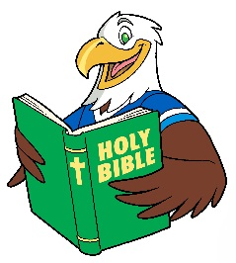
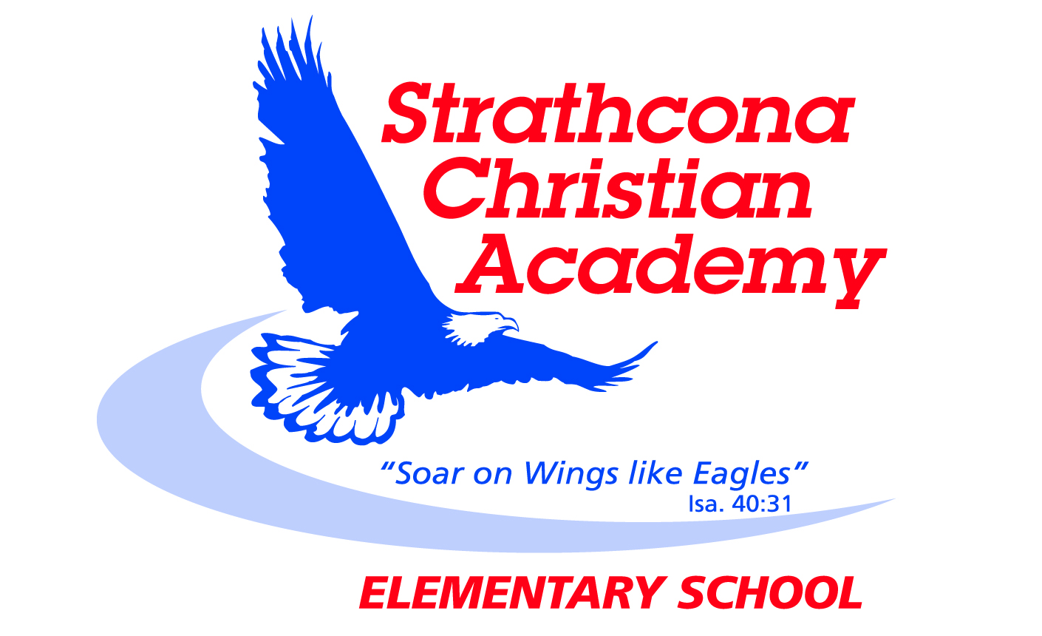
Grade 5 Bible Memory

Month | Week | Verse
SEPTEMBER | Week 1 | 2 Timothy 3:16*  All Scripture is God-breathed and is useful for teaching, rebuking, correcting and training in righteousness
 | Week 2 | 2 Timothy 3:17*  So that the servant of God may be thoroughly equipped for every good work.
 | Week 3 | Micah 6:8*  He has shown you, O man, what is good. And what does the Lord require of you? To act justly and to love mercy  and to walk humbly with your God.
OCTOBER | Week 1 | Psalm 119:11*  I have hidden your word in my heart that I might not sin against you.
 | Week 2 | Genesis 1:1*  In the beginning God created the heavens and the earth.
 | Week 3 | Philippians 4:13*  I can do everything through him who gives me strength.
NOVEMBER | Week 1 | 1 Corinthians 10:13*  No temptation has overtaken you except what is common to mankind. And God is faithful; he will not let you be tempted beyond what you can bear. But when you are tempted, he will also provide a way out so that you can endure it.
 | Week 2 | John 14:6  Jesus answered, “I am the way and the truth and the life. No one comes to the Father except through me.
 | Week 3 | Romans 3:23  For all have sinned and fall short of the glory of God.
DECEMBER | Week 1 | Romans 6:23  For the wages of sin is death, but the gift of God is eternal life in Christ Jesus our Lord.
 | Week 2 | Romans 5:8  But God demonstrates his own love for us in this: While we were still sinners, Christ died for us.
 | Week 3 | Romans 10:9  If you declare with your mouth, “Jesus is Lord,” and believe in your heart that God raised him from the dead, you will be saved.
JANUARY | Week 1 | John 3:16  For God so loved the world that he gave his one and only Son, that whoever believes in him shall not perish but have eternal life.
 | Week 2 | Matthew 22:37  Jesus replied: “‘Love the Lord your God with all your heart and with all your soul and with all your mind.’
 | Week 3 | Matthew 22:38  This is the first and greatest commandment.
FEBRUARY | Week 1 | Matthew 22:39  And the second is like it: ‘Love your neighbor as yourself.’
 | Week 2 | Matthew 22:40  All the Law and the Prophets hang on these two commandments.”
 | Week 3 | Matthew 22:37-40  ³⁷ Jesus replied: “‘Love the Lord your God with all your heart and with all your soul and with all your mind.’ ³⁸ This is the first and greatest commandment. ³⁹ And the second is like it: ‘Love your neighbor as yourself.’ ⁴⁰ All the Law and the Prophets hang on these two commandments.”
MARCH  MARCH | Week 1 | John 14:6  Jesus answered, “I am the way and the truth and the life. No one comes to the Father except through me.”
 | Week 2 | Romans 3:23  For all have sinned and fall short of the glory of God.
 | Week 3 | Romans 6:23  For the wages of sin is death, but the gift of God is eternal life in Christ Jesus our Lord.
APRIL | Week 1 | Romans 5:8  But God demonstrates his own love for us in this: While we were still sinners, Christ died for us.
 | Week 2 | Romans 10:9  If you declare with your mouth, “Jesus is Lord,” and believe in your heart that God raised him from the dead, you will be saved.
 | Week 3 | 2 Timothy 3:16, 17*  ¹⁶ All Scripture is God-breathed and is useful for teaching, rebuking, correcting and training in righteousness, ¹⁷ so that the servant of God may be thoroughly equipped for every good work.
MAY | Week 1 | Micah 6:8*  He has shown you, O man, what is good. And what does the Lord require of you? To act justly and to love mercy  and to walk humbly with your God.
 | Week 2 | Psalm 119:11*  I have hidden your word in my heart that I might not sin against you.
 | Week 3 | Genesis 1:1*  In the beginning God created the heavens and the earth.
JUNE | Week 1 | Philippians 4:13*  I can do everything through him who gives me strength.
 | Week 2 | 1 Corinthians 10:13*  No temptation has overtaken you except what is common to mankind. And God is faithful; he will not let you be tempted beyond what you can bear. But when you are tempted, he will also provide a way out so that you can endure it.
 | Week 3 | Review

* identifies new verses
Updated September 2014

