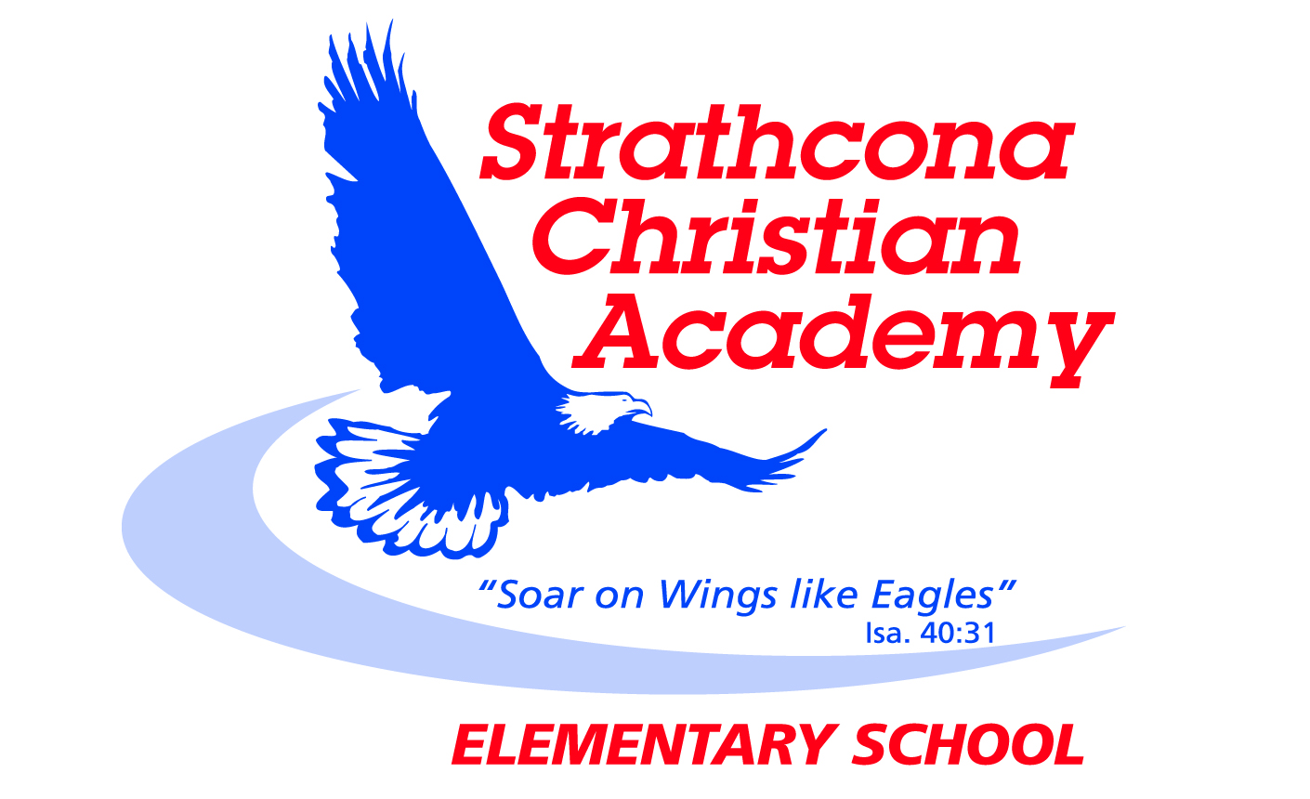
Grade 4 Bible Memory

Month | Week | Verse
SEPTEMBER | Week 1 | John 14:6*  Jesus answered, “I am the way and the truth and the life. No one comes to the Father except through me.
 | Week 2 | Romans 3:23*  For all have sinned and fall short of the glory of God.
 | Week 3 | Romans 6:23*  For the wages of sin is death, but the gift of God is eternal life in Christ Jesus our Lord.
OCTOBER | Week 1 | Romans 5:8*  But God demonstrates his own love for us in this: While we were still sinners, Christ died for us.
 | Week 2 | Romans 10:9*  If you declare with your mouth, “Jesus is Lord,” and believe in your heart that God raised him from the dead, you will be saved.
 | Week 3 | 1 Corinthians 13:4  Love is patient, love is kind. It does not envy, it does not boast, it is not proud.
NOVEMBER | Week 1 | 1 Corinthians 13:5  It does not dishonor others, it is not self-seeking, it is not easily angered, it keeps no record of wrongs.
 | Week 2 | 1 Corinthians 13:6  Love does not delight in evil but rejoices with the truth.
 | Week 3 | 1 Corinthians 13:7  It always protects, always trusts, always hopes, always perseveres.
DECEMBER  DECEMBER | Week 1 | 1 Corinthians 13:8a  Love never fails.
 | Week 2 | 1 Corinthians 13:4-8a  ⁴ Love is patient, love is kind. It does not envy, it does not boast, it is not proud. . ⁵ It does not dishonor others, it is not self-seeking, it is not easily angered, it keeps no record of wrongs. ⁶ Love does not delight in evil but rejoices with the truth. ⁷ It always protects, always trusts, always hopes, always perseveres. ⁸ Love never fails.
 | Week 3 | John 3:16  For God so loved the world that he gave his one and only Son, that whoever believes in him shall not perish but have eternal life.
JANUARY | Week 1 | Matthew 22:37, 38  ³⁷ Jesus replied: “‘Love the Lord your God with all your heart and with all your soul and with all your mind.’³⁸ This is the first and greatest commandment.
 | Week 2 | Matthew 22:39, 40  ³⁹ And the second is like it: ‘Love your neighbor as yourself.’ ⁴⁰ All the Law and the Prophets hang on these two commandments.”
 | Week 3 | Matthew 28:19  Therefore go and make disciples of all nations, baptizing them in the name of the Father and of the Son and of the Holy Spirit.
FEBRUARY | Week 1 | Matthew 7:12  So in everything, do to others what you would have them do to you, for this sums up the Law and the Prophets.
 | Week 2 | Galatians 5:22, 23  ²² But the fruit of the Spirit is love, joy, peace, patience, kindness, goodness, faithfulness, ²³ gentleness and self-control. Against such things there is no law.
 | Week 3 | 1 Corinthians 13:4, 5  ⁴ Love is patient, love is kind. It does not envy, it does not boast, it is not proud. . ⁵ It does not dishonor others, it is not self-seeking, it is not easily angered, it keeps no record of wrongs.
MARCH | Week 1 | 1 Corinthians 13:5, 6  ⁵ It does not dishonor others, it is not self-seeking, it is not easily angered, it keeps no record of wrongs. ⁶ Love does not delight in evil but rejoices with the truth.
 | Week 2 | 1 Corinthians 13: 7, 8a  ⁷ It always protects, always trusts, always hopes, always perseveres. ⁸ Love never fails.
 | Week 3 | John 3:16  For God so loved the world that he gave his one and only Son, that whoever believes in him shall not perish but have eternal life.
APRIL | Week 1 | Matthew 22:37-40  ³⁷ Jesus replied: “‘Love the Lord your God with all your heart and with all your soul and with all your mind.’³⁸ This is the first and greatest commandment. ³⁹ And the second is like it: ‘Love your neighbor as yourself.’ ⁴⁰ All the Law and the Prophets hang on these two commandments.”
 | Week 2 | Matthew 28:19  Therefore go and make disciples of all nations, baptizing them in the name of the Father and of the Son and of the Holy Spirit.
 | Week 3 | Matthew 7:12  So in everything, do to others what you would have them do to you, for this sums up the Law and the Prophets.
MAY | Week 1 | Galatians 5:22, 23  ²² But the fruit of the Spirit is love, joy, peace, patience, kindness, goodness, faithfulness, ²³ gentleness and self-control. Against such things there is no law.
 | Week 2 | Romans 3:23*  For all have sinned and fall short of the glory of God.
 | Week 3 | Romans 6:23*  For the wages of sin is death, but the gift of God is eternal life in Christ Jesus our Lord.
JUNE | Week 1 | Romans 5:8*  But God demonstrates his own love for us in this: While we were still sinners, Christ died for us.
 | Week 2 | Romans 10:9*  If you declare with your mouth, “Jesus is Lord,” and believe in your heart that God raised him from the dead, you will be saved.
 | Week 3 | John 14:6*  Jesus answered, “I am the way and the truth and the life. No one comes to the Father except through me.

* identifies new verses
Updated September 2014

