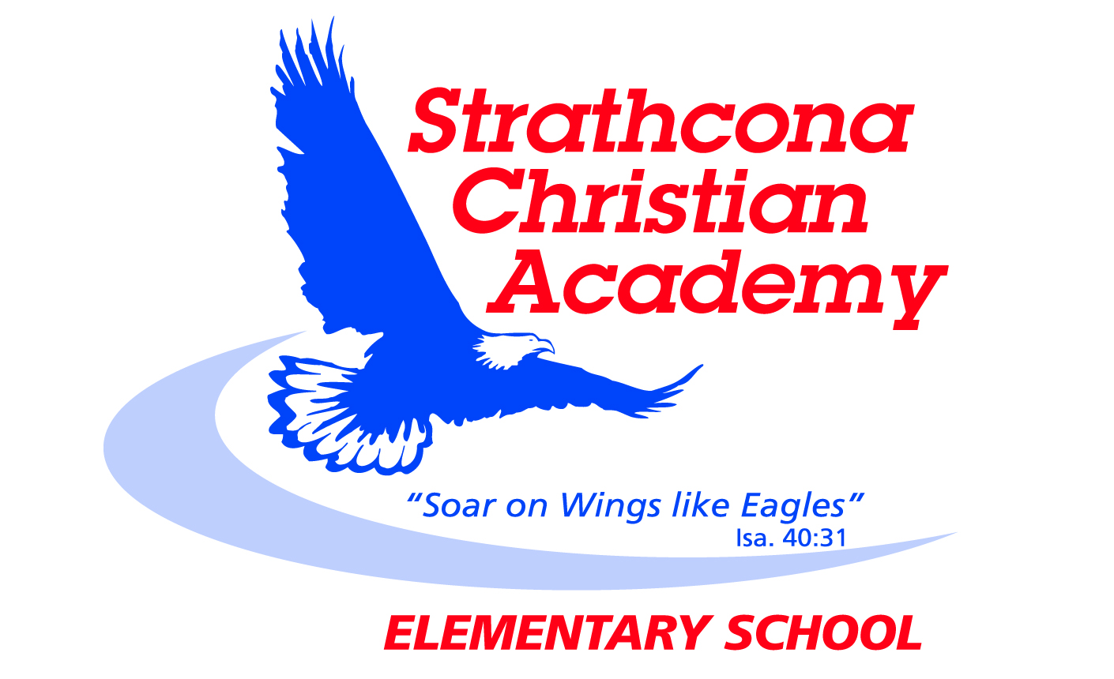
Grade 3 Bible Memory

Month | Week | Verse
SEPTEMBER | Week 1 | Psalm 139:1*  You have searched me, Lord, and you know me.
 | Week 2 | Psalm 139:2*  You know when I sit and when I rise; you perceive my thoughts from afar.
 | Week 3 | Psalm 139:3*  You discern my going out and my lying down; you are familiar with all my ways.
OCTOBER | Week 1 | Psalm 139:4*  Before a word is on my tongue you, Lord, know it completely.
 | Week 2 | Psalm 139:5*  You hem me in behind and before, and you lay your hand upon me.
 | Week 3 | Psalm 139:6*  Such knowledge is too wonderful for me, too lofty for me to attain.
NOVEMBER  NOVEMBER | Week 1 | Psalm 139:1-6*  You have searched me, Lord, and you know me.  ² You know when I sit and when I rise; you perceive my thoughts from afar. ³ You discern my going out and my lying down; you are familiar with all my ways. ⁴ Before a word is on my tongue you, Lord, know it completely. ⁵ You hem me in behind and before, and you lay your hand upon me. ⁶ Such knowledge is too wonderful for me, too lofty for me to attain.
 | Week 2 | John 3:16  For God so loved the world that he gave his one and only Son, that whoever believes in him shall not perish but have eternal life.
 | Week 3 | Matthew 22:37  Jesus replied: “‘Love the Lord your God with all your heart and with all your soul and with all your mind.’
DECEMBER | Week 1 | Matthew 22:38  This is the first and greatest commandment.
 | Week 2 | Matthew 22:39  And the second is like it: ‘Love your neighbor as yourself.’
 | Week 3 | Matthew 22:40  All the Law and the Prophets hang on these two commandments.
JANUARY | Week 1 | Matthew 28:19  Therefore go and make disciples of all nations, baptizing them in the name of the Father and of the Son and of the Holy Spirit.
 | Week 2 | Matthew 7:12  So in everything, do to others what you would have them do to you, for this sums up the Law and the Prophets.
 | Week 3 | Galatians 5:22-23a  But the fruit of the Spirit is love, joy, peace, patience, kindness, goodness, faithfulness, gentleness and self-control.
FEBRUARY | Week 1 | Galatians 5:23b  Against such things there is no law.
 | Week 2 | Galatians 5:22-23  ²² But the fruit of the Spirit is love, joy, peace, patience, kindness, goodness, faithfulness, ²³ gentleness and self-control. Against such things there is no law.
 | Week 3
MARCH  MARCH | Week 1 | Psalm 139:1*  You have searched me, Lord, and you know me.
 | Week 2 | Psalm 139:2*  You know when I sit and when I rise; you perceive my thoughts from afar.
 | Week 3 | Psalm 139:3*  You discern my going out and my lying down; you are familiar with all my ways.
APRIL | Week 1 | Psalm 139:4*  Before a word is on my tongue you, Lord, know it completely.
 | Week 2 | Psalm 139:5*  You hem me in behind and before, and you lay your hand upon me.
 | Week 3 | Psalm 139:6*  Such knowledge is too wonderful for me, too lofty for me to attain.
MAY | Week 1 | Psalm 139:1-6*  You have searched me, Lord, and you know me.  ² You know when I sit and when I rise; you perceive my thoughts from afar. ³ You discern my going out and my lying down; you are familiar with all my ways. ⁴ Before a word is on my tongue you, Lord, know it completely. ⁵ You hem me in behind and before, and you lay your hand upon me. ⁶ Such knowledge is too wonderful for me, too lofty for me to attain.
 | Week 2 | John 3:16  For God so loved the world that he gave his one and only Son, that whoever believes in him shall not perish but have eternal life.
 | Week 3 | Matthew 22:37-40  ³⁷ Jesus replied: “‘Love the Lord your God with all your heart and with all your soul and with all your mind.’ ³⁸ This is the first and greatest commandment. ³⁹ And the second is like it: ‘Love your neighbor as yourself.’ ⁴⁰ All the Law and the Prophets hang on these two commandments.”
JUNE  JUNE | Week 1 | Matthew 28:19  Therefore go and make disciples of all nations, baptizing them in the name of the Father and of the Son and of the Holy Spirit.
 | Week 2 | Matthew 7:12  So in everything, do to others what you would have them do to you, for this sums up the Law and the Prophets.
 | Week 3 | Galatians 5:22-23  ²² But the fruit of the Spirit is love, joy, peace, patience, kindness, goodness, faithfulness, ²³ gentleness and self-control. Against such things there is no law.

* identifies new verses
Updated September 2014

